Analysis of My Spotify Streaming history using SQL and Tableau

I joined Spotify last year, I was curious to know more about my streaming habit, so I set out to perform an exploratory analysis to answer some questions to help me understand how I listen to music

I wanted to find out

1. Total unique artists.
2. Total unique songs.
3. The timeline of my streaming.
4. What day I listened to music the most.
5. My favorite artist.
6. Top song.

About the data

One of the beautiful things I love about Spotify is the ability to request a download of all my streaming history. Anyone can ask for their data for personal use through their developer platform.

The data was in JSON format, and I converted it to CSV using <https://retool.com/utilities/json-to-csv>.

There are three datasets with four columns each, four columns include:

1. endTime - Date and time of when the stream ended
2. artistName - Name of "creator" for each stream (e.g., the artist's name if a music track).
3. trackName - Name of items listened to or watched (e.g., the title of music track or name of the video)
4. msPlayed - Stands for how many milliseconds the track was heard.

I used SQL to clean the data according to my needs. The code used for cleaning can be found on my GitHub page, link to the repo containing the code: CLICK HERE

During my analysis, I discovered between February 2021 and January 2022, I have spent approximately 84,513.55 minutes (about 58 days!) listening to music. It is not too surprising to me because I love music. In that same period, I listened to 3,813 unique artists and 9,506 unique songs, but in total, I listened to 26,201 songs.

My streaming history timeline

I know I spend a lot of time listening to music listening to music. I didn't realize it was this much time! (84,513.55 minutes between February 2021 and January 2022).

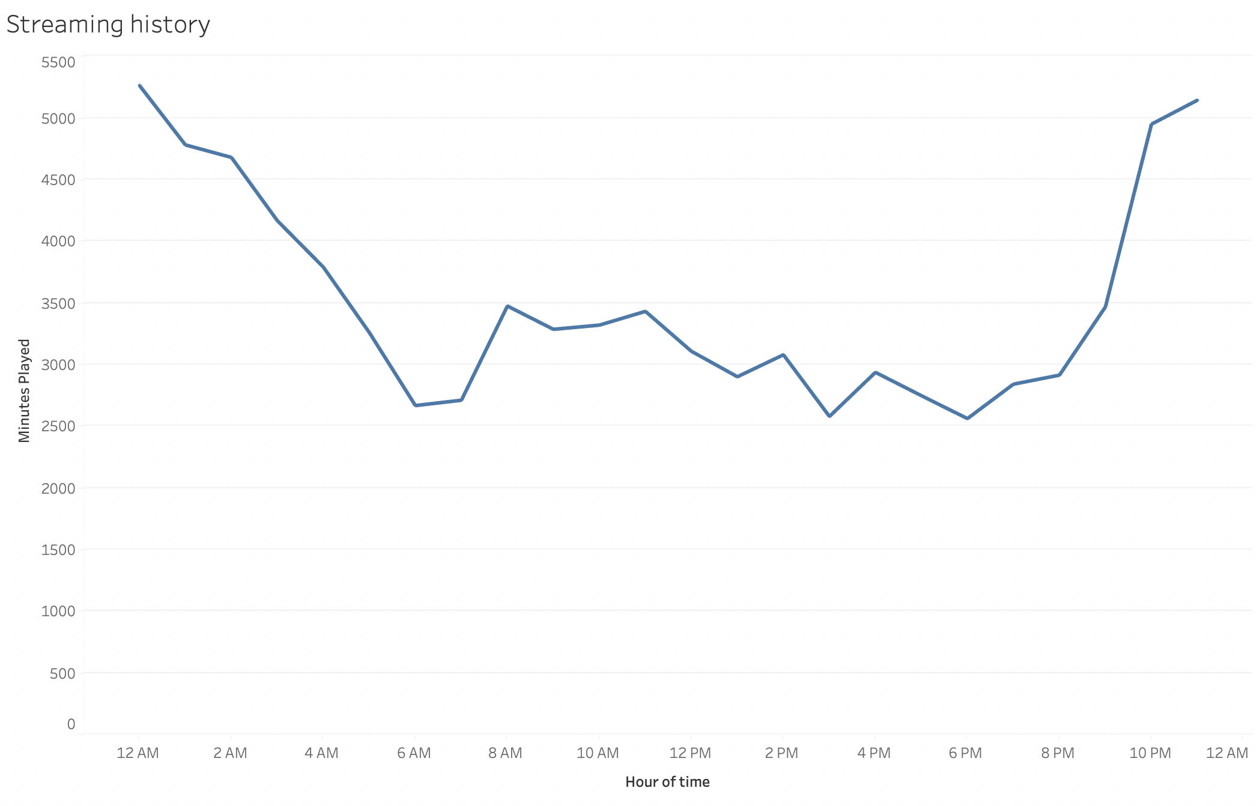

To be fair, music helps me sleep at night, so there is a massive spike when I go to bed and when I wake up.

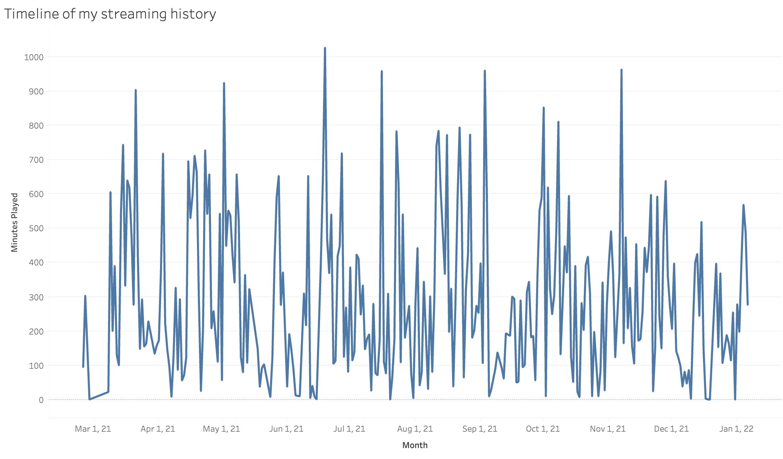

On June 19th, 2021, I spent a gasping 1,027 minutes (about 17hours) listening to music – the most in the past year! There are similar spikes in listening times, and they almost all happen on weekends (Friday, Saturday, and Sundays) when I am mostly at home. I am not surprised as listening to music is my favorite pastime. I turn on music in the background while working on projects, cleaning, or surfing the web.

Day preference

Does the day of a week affect how I listen to music?

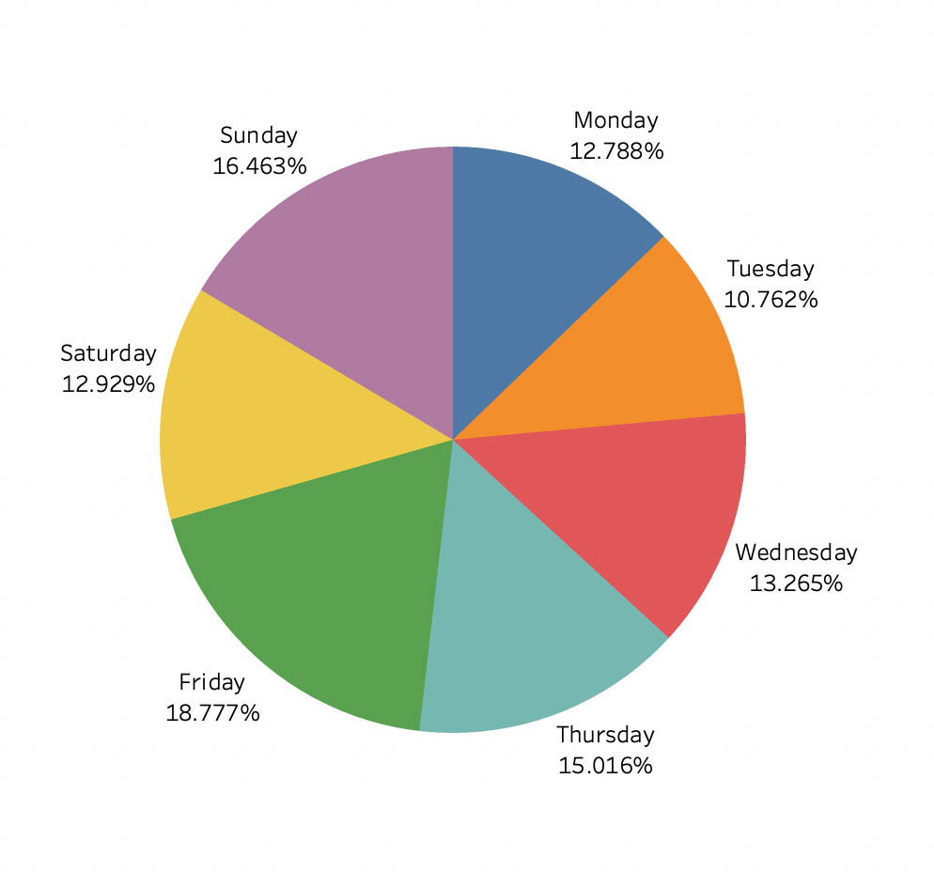

I listen to music wherever I go. It makes sense Monday – Wednesday recorded the lowest listening time because those are the days I am mostly busy with school. I am shocked, though, on Saturday's record. I suppose because visitors and chores caused the low listening time.

Favorite artists

Do I have a favorite artist?

According to the data, I do. I considered two factors to determine this:

1. The number of times I played an artist's song
2. The number of minutes I spent listening to an artist song

The graphs below show the top 15 artists under both categories

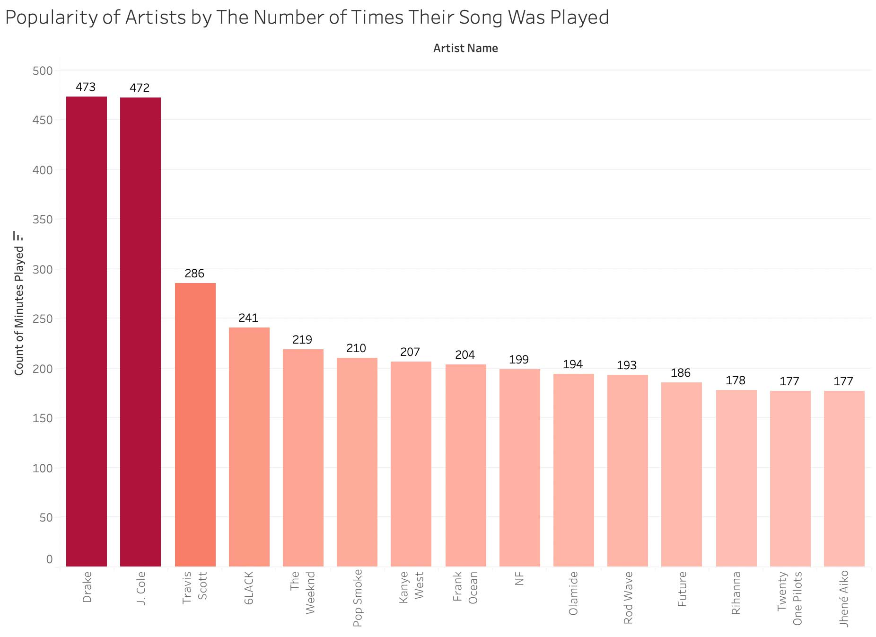

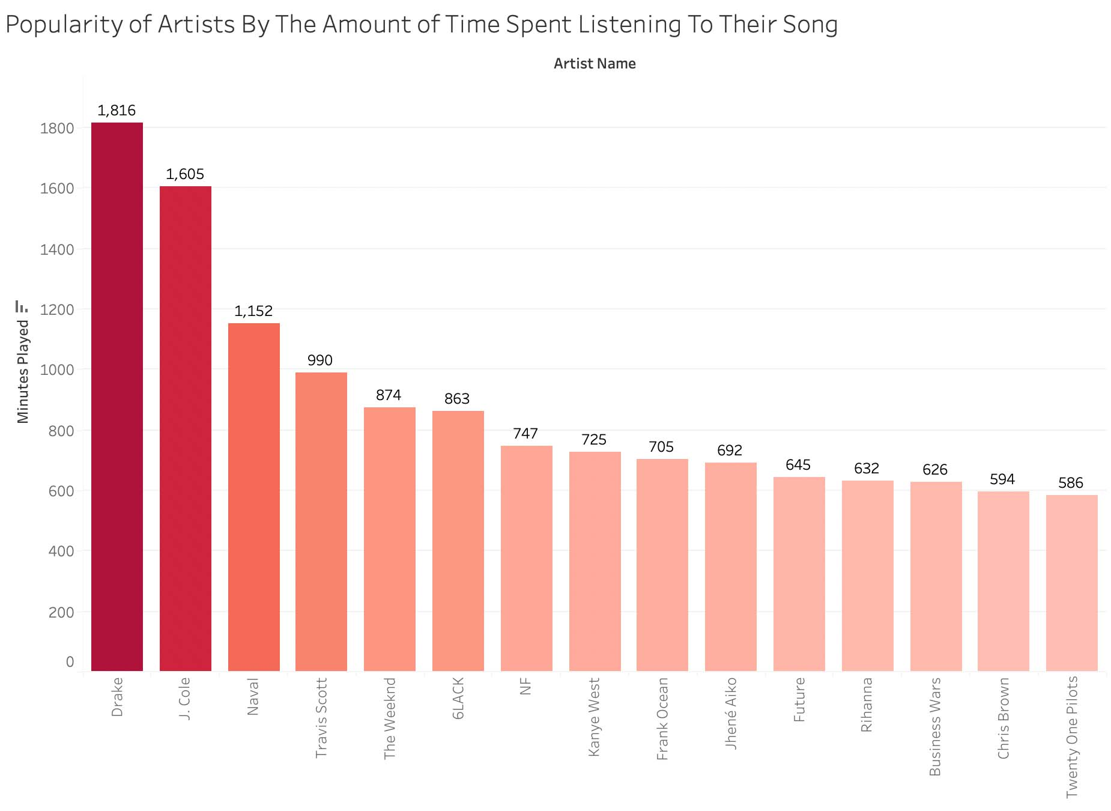

Drake and J. Cole maintained the top positions on both graphs. The thing starts to rearrange after the top two because I listen to the podcast. Naval and Business Wars are some of the podcasts I listen to; although I don't click on them as often, it shows I listen to the podcasts for a significant amount of time (an average podcast lasts an hour).

What songs were played the most?

Was it by the same artists?

It is complicated

Some of the top artists I listen to made the chart, but it was populated mainly by podcast episodes and viral songs I classify as earworms.

The top song (in this case podcast), How to Get Rich, accounted for 40% of the time I spent listening to the artist Naval. Although Young Stoner Boy featured drake in the song Solid, it charted as top 3, goes to show how much I like drake. Lemon Pepper Freestyle by Drake was in the chart too. I never thought my most listened to song would be a podcast, but it was expected given the average listening time of a podcast.

Conclusion

I had fun working on this project as it was personal to me. I enjoyed learning more about my music preferences. The quantifiable figure of how much time I spend on music surprised me, I know I loved listening to music, but I had no idea it was this much!

Tableau dashboard to interact with any of the chart <https://public.tableau.com/app/profile/uchechukwu.cos.ibe/viz/spotifyanalysis_16421777483760/Dashboard1?publish=yes>

GitHub link to check out the dataset or cleaning code